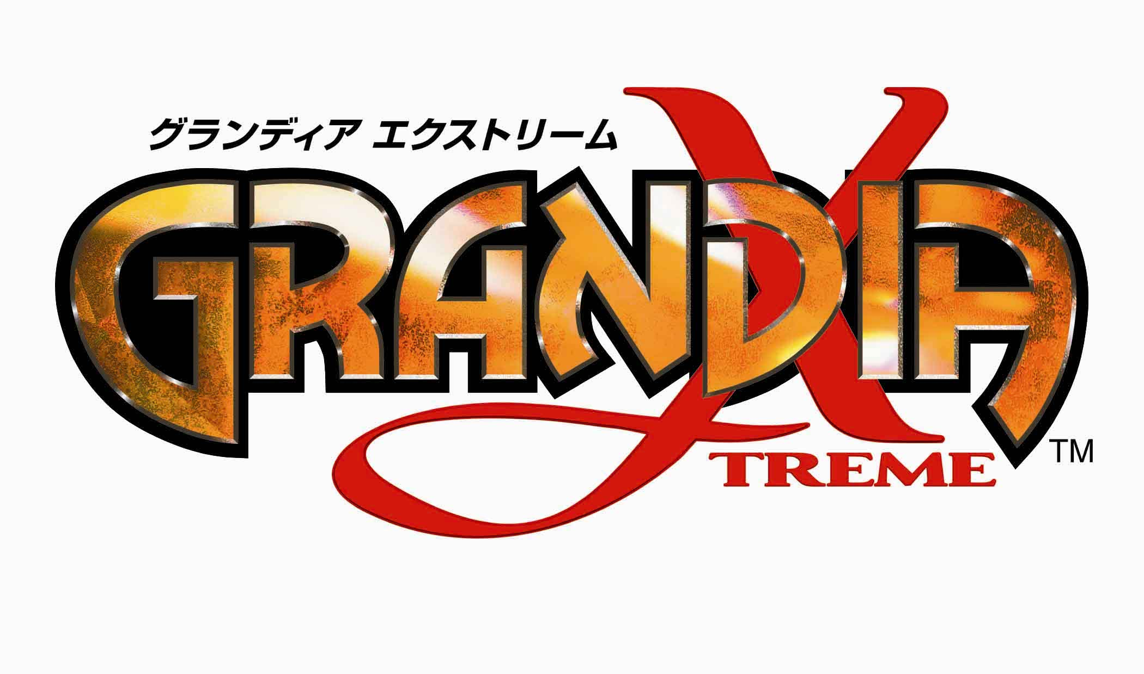

Publisher: Enix America Inc.
Developer: Game Arts
Release: September ‘02
Platform: PlayStation® 2
Genre: Role Playing Game
ESRB: Rating Pending
# of Players: 1

Contacts: Laura Heeb, HighWater Group
laura@highwatergroup.com or 212-338-0077

Justin Lucas, Enix America Inc.
Lucas@enix.com or 206-861-1274
Overview:
A pause in the ancient conflict between Nortis and Arcada ends when a new spiritual power is discovered emanating from Locca. Suddenly, a string of natural calamities plague the land causing an elemental shift. You are Evann, a master of elemental forces and an unlikely hero. Gather a team of forces and travel to Locca to discover the source of evil magic!

With over 130 different types of monsters and eight elemental lands standing between you and victory, the future of the world has never looked more desperate. Can you avert the disaster rising from the ancient ruins?

Features:
- From the producers of Dragon Warrior, Star Ocean and Valkyrie Profile, and the creators of the Grandia and Lunar RPG series comes the first original Grandia title for PS2 – Grandia Xtreme;
- Dramatic story-driven adventure developed by the team that created the original Grandia;
- 360-degree viewing radius. Fully rendered 3-D utilizes the polygon-pushing power of PS2 so that the user can freely rotate the camera angle;
- Sophisticated AI options ranging from ‘Totally Aggressive’ to ‘Safety First’. Two AI settings can be configured for each player and players can switch between both settings;
- Map function for exploration – alerts you of the presence of enemies;
- Deep character skill development system:
- Read skill books to enable skills for each character to cultivate however you want!
- Innovative strategy sessions as occur as players discuss issues and find out what actions they should take next while having a meal together;
- Innovative and accessible game design allows both “hard-core” RPG fans and casual gamers to truly enjoy playing Grandia Xtreme;
- Unique combat system that captures the chaotic nature of group combat and combines it with the finest elements of real-time and turn-based combat systems:
- Initiative Point system for determining who attacks first
- Utilize elemental power of Fire, Air, Earth and Water to battle against enemies
- Combat can be avoided if the user chooses
- Bonuses for timing and combos
- Quick load times between scenes and into combat.
# # #

